LAB TEMPLATE

[Enter name of Lab] Lab

INSTRUCTIONS
Each section of the page has been broken down into “blocks” of content. A block is a way to display content on a website page. The template includes all possible content blocks, including some that are optional. For those blocks labeled as optional, if you do not have content to include, please select the “Do Not Include” option.

For each block, we’ve included a screenshot showing how it appears in the content mockup. The table below the screenshot lists the areas that need your input. Please enter your content in the areas highlighted in yellow. Additional instructions for the content are listed below the highlighted area and are italicized. If you do not have content to Optional areas are marked in red in the table.

PAGE META DATA
Website metadata is descriptive data about a webpage that helps search engines (like Google) and browsers understand, categorize, and display content. Metadata lives in the background of the site.
Page Title | 50-60 characters | Center for Clinical Spectroscopy | Brigham and Women's Hospital
Meta Description | 150-160 characters | The Center for Clinical Spectroscopy at BWH translates magnetic resonance spectroscopy (MRS) into clinical practice through technology development and advocacy.

ON PAGE CONTENT
Block 1: Page heading
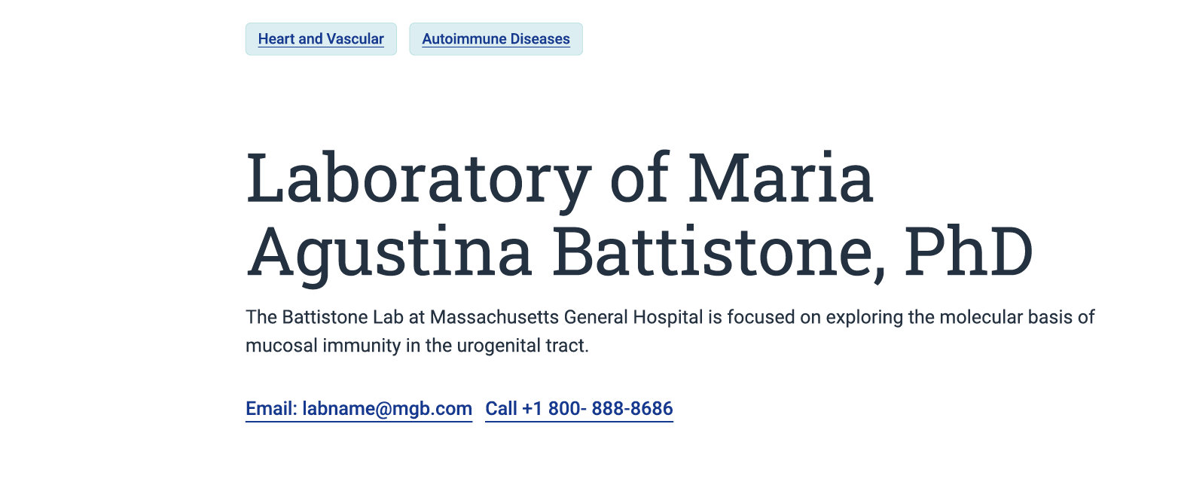
Tags are used for search filters to help users find appropriately related material
Department/Institute Tag | Department of Radiology  Department/Institute Name
Main Research Area Tag | Magnetic Resonance Spectroscopy (MRS)  Indicate main research area

Title  (char limit: 139) | Center for Clinical Spectroscopy  Lab Name
Description (optional) (char limit: 512) | A multidisciplinary team dedicated to bridging the gap between MRS research and clinical practice through innovation and education.  Include 1-2 short sentences

Department contact information (Optional)
CTA – Text | Email: cci@bwh.harvard.edu
CTA – Text | Call: 617-732-8750

Block 2: Body Copy/Text

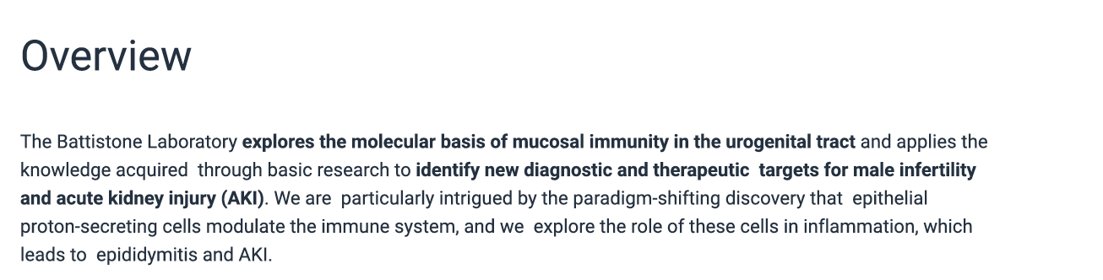
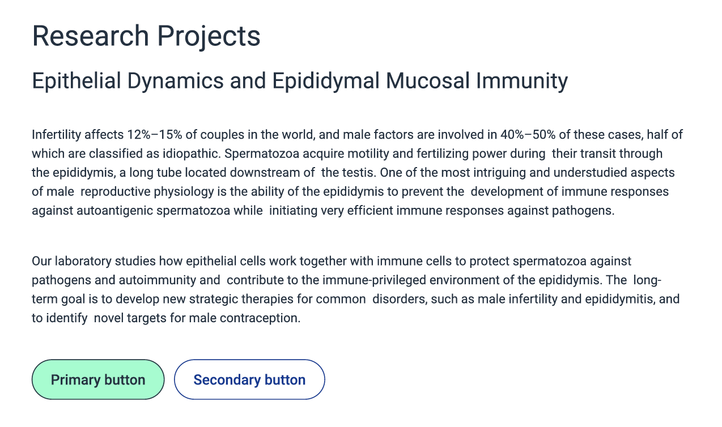
Body copy | Overview  The Center for Clinical Spectroscopy (CCS) is focused on three major pillars: technology development, clinical translation, and advocacy. Our multidisciplinary team works to develop novel MR spectroscopy hardware and software that increases signal-to-noise ratios, enabling significant improvements over conventional methods.  Research projects (optional)  • Traumatic Brain Injury & PTSD: Studying biomarkers to distinguish between PTSD and mild TBI in military veterans.  • Chronic Traumatic Encephalopathy (CTE): Investigating the clinical presentation and biomarkers of CTE in collaboration with the NIH.  • Neurodegenerative Diseases: Advancing neuroimaging for Alzheimer's disease and evaluating central nervous system changes.

Button link (optional) – Text (rec char limit: 40) | Text goes here
Button link URL (optional) | Provide URL for link

Block 3: Featured Research (Optional)
(example – other content to be featured with a video)
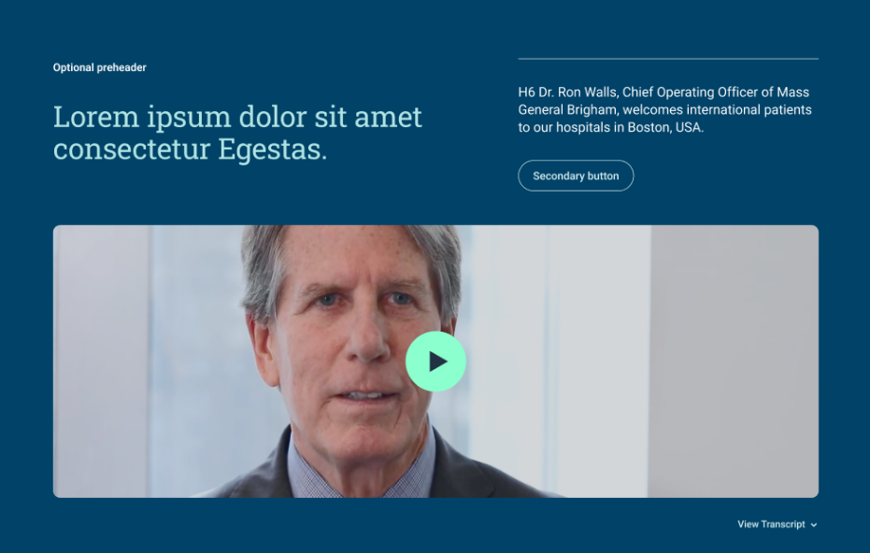
NOTE: If included, you will need to update on a regular basis
Do you wish to include this block on your page?*

Headline | Pathways in Spectroscopy: Innovating Clinical Diagnostics
Description | Watch our latest feature on how magnetic resonance spectroscopy is transitioning from academic research to a vital clinical tool for diagnosing neurological disorders.
Button Link text (optional) | Explore Our Technology
Button Link URL (optional) | https://www.brighamandwomens.org/radiology/research/center-for-clinical-spectroscopy/technology
Video | [Insert link to "Pathways in Spectroscopy" or Lab Overview video]
Video alt text | A scientist explains the Visual Evaluative Control Technology Of Resonance Spectroscopy (VECTORS) pipeline.  short (<100 chars) descriptive text for screen reader users
Transcript (optional) | Included for accessibility compliance.  Adding transcripts helps make content more accessible when the video has spoken content or important audio information

Block 4: Research Team/Bio Grid Block
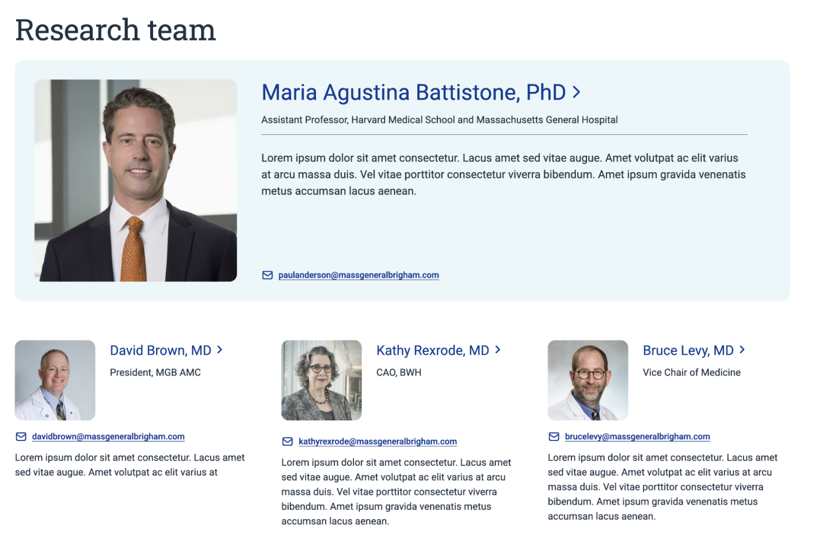
Provide details for each lab member below. Add additional members as needed

Expert(s) | [List out names of lab faculty, including:]  - Name  - Entity association (MGH, CAO etc.)  - Email address  - Short description (optional)  Please identify featured lab faculty/researcher as shown in image, if using featured option).
Featured Expert: | Alexander P. Lin, PhD  • Title: Director, Center for Clinical Spectroscopy  • Entity Association: BWH Radiology / Harvard Medical School  • Short Description: Dr. Lin specializes in clinical applications of multinuclear MRS in the brain, breast, and liver.

Block 5: Publications/Open Positions Block (optional)

The recommendation is to link to Pubmed for publications. If you choose to list selected publications on the page, this will require regular updating

Body copy (RTE Advanced) | Publications  pubmed.ncbi.nlm.nih.gov"Center+for+Clinical+Spectroscopy"+AND+Brigham  Open Positions  • Automated Quality Control: "A novel automated pipeline to assess MR spectroscopy quality control: Comparing current standards and manual assessment" (2024).  • Clinical Biomarkers: "Cystathionine: A Spectroscopic Biomarker for 1p/19q Codeleted Gliomas" (2023).  • Neurometabolic Research: "Neurometabolic alterations in children and adolescents with functional neurological disorder" (2024).  - • A novel automated pipeline to assess MR spectroscopy... (2024): Proposes a new quality control pipeline named VECTORS.  - • A Spectroscopic Biomarker for 1p/19q Codeleted Gliomas (2023): Research identifying biomarkers for specific brain tumors.  - • Magnetic Resonance Spectroscopy as a Biomarker... (2017): A review of MRS utility in chronic traumatic encephalopathy.  - Overcoming Technical Challenges of MR Spectroscopy... (2019): Addressing clinical implementation hurdles.

Block 6: Callout block

Standard values for “contact us call out” are included below. Areas to fill in are highlighted in yellow.

Overview
Title (rec char limit: 81) | How to reach us
Description text (rec char limit: 355) | Contact us with inquiries about ongoing studies, collaboration opportunities, or lab resources.
CTA – Text (rec char limit: 40) | Email: cci@bwh.harvard.edu
CTA – Text (rec char limit: 40) | Call: 617-732-8750

